**Association Rules**

**Example-Groceries Dataset**

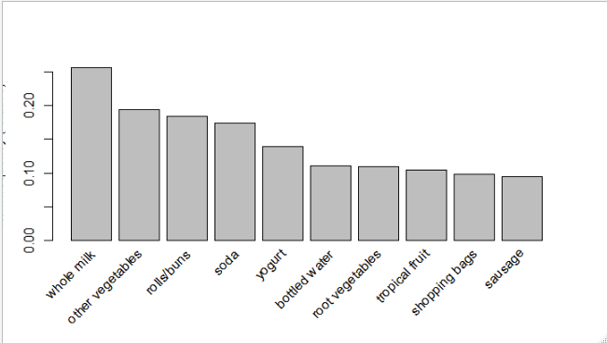

**Above plot shows the item buying frequency.**

**Based on Apriori algorithm with support 0.005 and confidence 0.05 and minimum length as 3 we are getting 840 rules.**

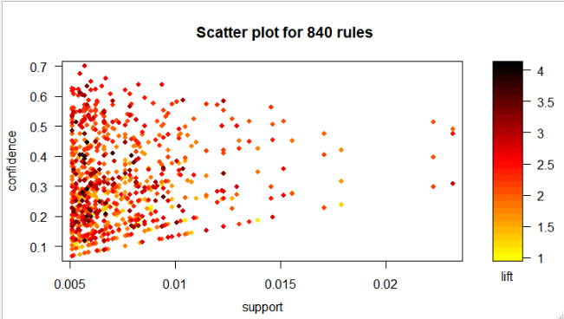

**> inspect(head(sort(Grules, by = "lift")))**

lhs rhs support confidence lift count

[1] {citrus fruit,

other vegetables,

whole milk} => {root vegetables} 0.005795628 0.4453125 4.085493 57

[2] {butter,

other vegetables} => {whipped/sour cream} 0.005795628 0.2893401 4.036397 57

[3] {other vegetables,

root vegetables} => {onions} 0.005693950 0.1201717 3.875044 56

[4] {citrus fruit,

pip fruit} => {tropical fruit} 0.005592272 0.4044118 3.854060 55

[5] {other vegetables,

tropical fruit,

whole milk} => {root vegetables} 0.007015760 0.4107143 3.768074 69

[6] {whipped/sour cream,

whole milk} => {butter} 0.006710727 0.2082019 3.757185 66

**> inspect(head(sort(Grules, by = "confidence")))**

lhs rhs support confidence

[1] {root vegetables,tropical fruit,yogurt} => {whole milk} 0.005693950 0.7000000

[2] {other vegetables,pip fruit,root vegetables} => {whole milk} 0.005490595 0.6750000

[3] {butter,whipped/sour cream} => {whole milk} 0.006710727 0.6600000

[4] {pip fruit,whipped/sour cream} => {whole milk} 0.005998983 0.6483516

[5] {butter,yogurt} => {whole milk} 0.009354347 0.6388889

[6] {butter,root vegetables} => {whole milk} 0.008235892 0.6377953

lift count

[1] 2.739554 56

[2] 2.641713 54

[3] 2.583008 66

[4] 2.537421 59

[5] 2.500387 92

[6] 2.496107 81

**> inspect(head(sort(Grules, by = "support")))**

lhs rhs support confidence

[1] {other vegetables,root vegetables} => {whole milk} 0.02318251 0.4892704

[2] {root vegetables,whole milk} => {other vegetables} 0.02318251 0.4740125

[3] {other vegetables,whole milk} => {root vegetables} 0.02318251 0.3097826

[4] {other vegetables,yogurt} => {whole milk} 0.02226741 0.5128806

[5] {whole milk,yogurt} => {other vegetables} 0.02226741 0.3974592

[6] {other vegetables,whole milk} => {yogurt} 0.02226741 0.2975543

lift count

[1] 1.914833 228

[2] 2.449770 228

[3] 2.842082 228

[4] 2.007235 219

[5] 2.054131 219

[6] 2.132979 219

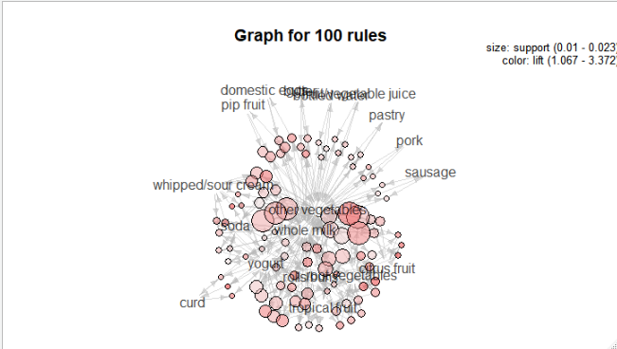

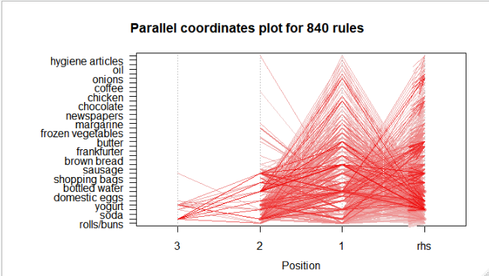

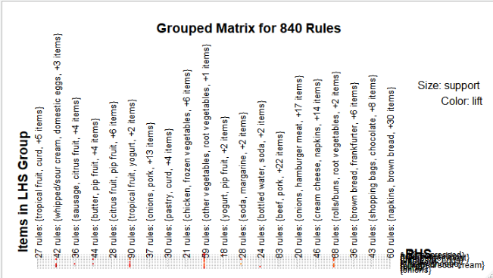

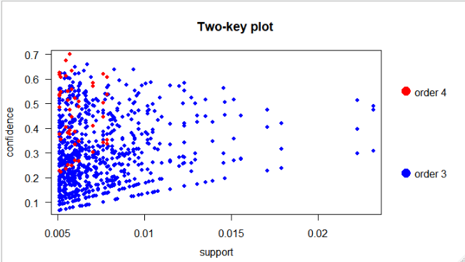

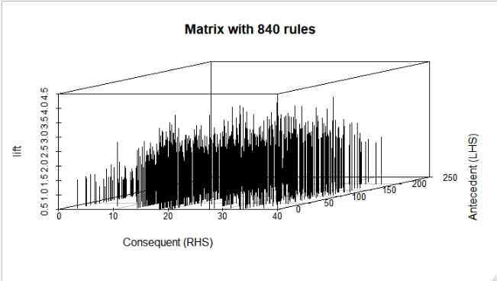

**inspect(yogurtrules[1:5])**

lhs rhs support confidence lift

[1] {cream cheese,yogurt} => {other vegetables} 0.005287239 0.4262295 2.202820

[2] {cream cheese,other vegetables} => {yogurt} 0.005287239 0.3851852 2.761149

[3] {other vegetables,yogurt} => {cream cheese} 0.005287239 0.1217799 3.071038

[4] {cream cheese,yogurt} => {whole milk} 0.006609049 0.5327869 2.085141

[5] {cream cheese,whole milk} => {yogurt} 0.006609049 0.4012346 2.876197

count

[1] 52

[2] 52

[3] 52

[4] 65

[5] 65

**People likely to buy Yogurt also likely to buy whole milk and other vegetables as well.**